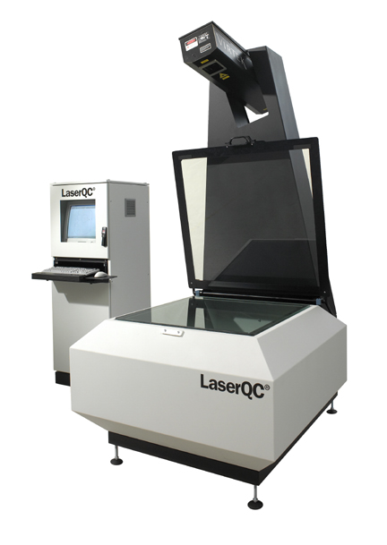
Professional Fabrications, Inc.
is excited to announce the addition of two pieces of equipment:

Virtek 2D Laser Inspection Machine

This state of the art inspection machine will allow us to improve quality inspections and increase throughput at all of our fabricating work centers. Lengthy 1st piece inspections will be a thing of the past. We now have the ability to inspect complicated parts in seconds vs. minutes, or even hours, increasing machine capacities. By scanning parts in X, Y and T directions, we will immediately know if our customers’ parts are fabricated within specified tolerances. With the click of a button, we can generate 1st piece inspection reports that can be electronically transferred to our customers. This machine also has the capability to reverse engineer products.

Toyokoki HYB-250 ton x 13 ft. Hybrid Electric/Hydraulic CNC Press Brake

This CNC press brake will give us an opportunity to expand our forming capacities in reference to both length and tonnage. Its design is unique, combining electric accuracy with hydraulic force to improve accuracy and speed. Although this machine is very large, it is also the fastest operating machine on the market, with a stroke speed of 426 IPM. This machine also features auto crowning, which allows our operators to adjust angles easily and efficiently, reducing lengthy set up times. With it’s CNC technology, we can program this brake offline to increase efficiencies on our shop floor.
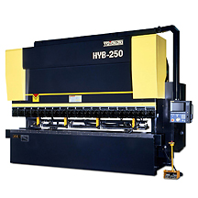

Press Force (ton) | 20
Bending Length (mm) | 4000
Stroke Length (mm) | 250
Backguage Stroke (mm) | 40
FULL PRODUCT SPECIFICATIONS

